**CHAPTER 1: INTRODUCTION**

**A. BACKGROUND OF THE ORGANIZATION:**

Independent University, Bangladesh (IUB) was established in 1993. It is one of the oldest Private Universities in Bangladesh, currently has more than an estimation of 7,048 undergraduate and graduate students and over 10,455 alumni. This student population is lately predicted to grow at about 10% annually. Since its inception, IUB has shown remarkable outcomes in producing graduates with marketable skills by being sincere, staying disciplined and up to date with the on-going curriculum and progress system.

IUB has five main school distinctions within under its name and they are as follows:

1. Business & Entrepreneurship
2. Engineering, Technology & Sciences
3. Environment and Life Sciences
4. Liberal Arts & Social Sciences
5. Pharmacy and Public Health.

IUB also provides massive percentage based tuition fee waivers and scholarships for a huge proportion of this students, more than most private universities of the country. This greatly helps the financial guarantors of the students to keep up with the expenses of studies.

Furthermore, IUB is also constantly developing and improving its lab facilities and flourishing on its curriculum according to current corporate world demands, greatly diminishing the outraging gap between academic curriculum and the professional job market.

**B. BACKGROUND OF THE PROJECT:**

Currently, the student marking monitoring system of IUB students are done completely manually through the means of excel files and previously determined PLOs and COs from the IEB, UGC and mapped by the respective department of each major. The stakeholders, department or any higher authorities does not have an automated system through which they can visualize the performance data of the students throughout the semesters. So we have to change that to an automated process for everybody’s convenience.

**C. OBJECTIVE OF THE PROJECT:**

The Student Performance Monitoring System (SPMS) that we are going to build will get all student performance data from the respective faculties and departments and vividly summarize and present all the performance data including various sorts of graphs to make it crystal clear for the Stakeholders and all the higher authorities to understand without much effort. The faculties no longer have to create vast excel sheets representing all the marks and CO/PLO achievements of each student manually, instead the faculty will just have input the marks of each student onto the SPMS and it will automatically do all the work for the faculty, making it tons more easier, faster and less hectic for the individuals. As it is all done by computer systems, the process will be instantaneous, unlike a very lengthy process from before, and all the stakeholders that has access to the system will be able to see the data right away without any issues.

**D. SCOPE OF THE PROJECT:**

As we have done a thorough analysis of the existing marking and evaluation system, and found out that there are several issues within the entire process which can lead to serious amounts waste in time and resources. Our proposed Web Application system known as the Student Performance Monitoring System (SPMS) will eradicate all these unnecessary consumption of resources and throw them to be done automatically at the system backend. The system will include a Relational Database Management System (RDBMS) server to store and edit/update all the performance information of the student in the enrolled courses. The Web Application will have seamless and intuitive User Panels or Graphical User Interfaces (GUIs) to make it easily operable for every stakeholder involved. Each individual user type will be able to observe and download all the student data in the way that is visualized extremely vividly and also that fits most suitable for them to understand. Moreover, all the data will be stored on server protected by high tier cyber security means, and each user type will have access to the specific data that is relevant to only them in order to maintain the best quality privacy for every user or stakeholder.

**CHAPTER 2: REQUIREMENT ANALYSIS**

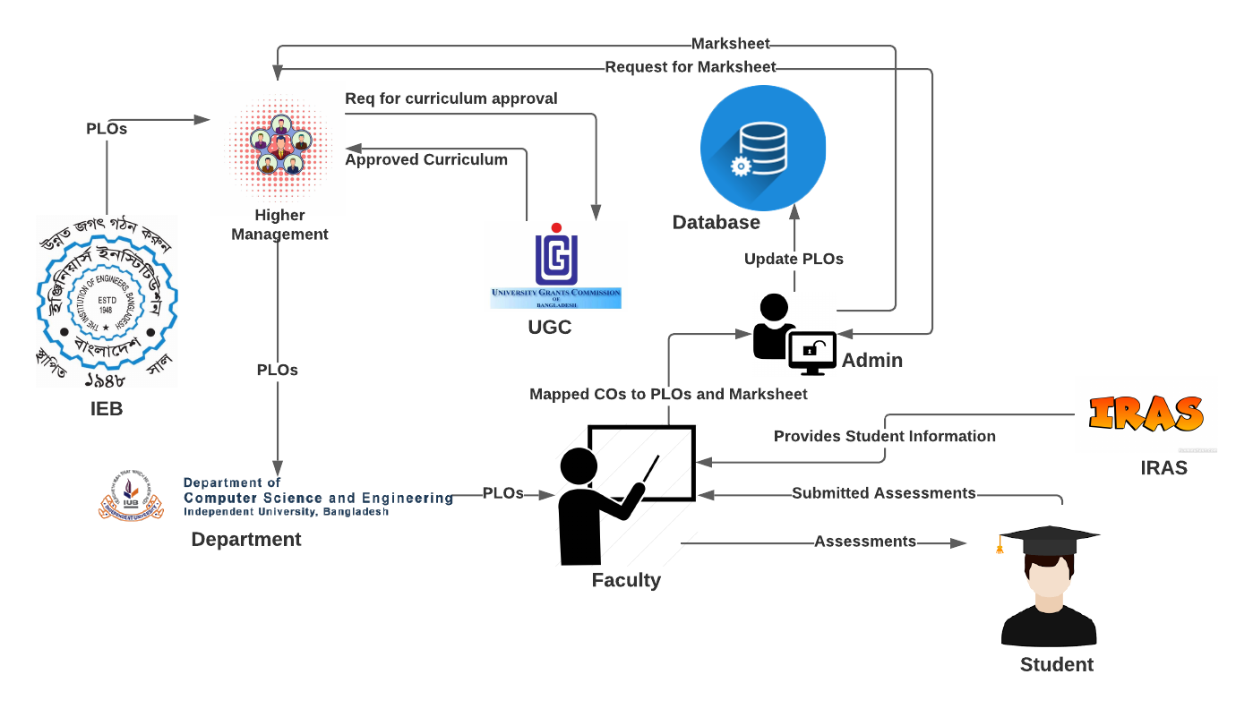**A. Existing Business System:**

Figure 1Rich Picture (AS_IS)

**B. Six Element Analysis of Existing Business:**

|  |  |  |  |  |  |  |
| --- | --- | --- | --- | --- | --- | --- |
| process | Human | Non-computing Hardware | Computing  Hardware | Software | Database | Communication  & Network |
| STUDENT’S ASSESSMENT | **1.Faculty :**  **a)**Create Question Paper.  a) Takes exam of  students in the  form of quizzes,  midterm and final  term by providing  questions.  b) Create  assessment report.  c) Send the  assessment report  to admin  **2.Student:**  a) Answers the questions  provided by  Faculty.  b) submit the answer paper to the faculty.  **3.Admin:**  a) Receives and  stores  assessment report  of students  provided by  Faculty.  b) Store the marks of the student in the Database. | **Paper:**  a) Used to  prepare hardcopy  of question  papers that are  used to assess  students in  exams.  b) Used to  prepare hardcopy  assessment  report.  c) Used to  provide hardcopy  of answer script  to the faculty.  **2.Stationery:**  a) Used to check  hardcopy of  answer script  provided by  students.  b) Used to fill  answer scripts  that are to be  provided to  faculty.  **3.Store Room:**  a) Used to store  all hardcopy of  questions, answer scripts  and assessment  reports. | **1.Computer:**  a) Used to  prepare softcopy  of question  papers that are  used to assess  students in  exams.  b) Used to  prepare softcopy  assessment  report.  c) Used to  prepare softcopy  of answer script  to the faculty.  d) Used to store  all softcopy of  questions,  answer scripts  and assessment  reports.  **2.Printer:**  a) Used to print  the questions on  to paper.  b) Used to print  the assessment  report.  c) Used to print  the answer script. | **1.Microsoft Word:**  a) Used to prepare  softcopy of question  papers that are used  to assess students in  exams.  b) Used to prepare  softcopy of answer  script to faculty.  **2.Microsoft Excel** :  a) Used to prepare  softcopy assessment  report.  **3.Gmail :**  a) Used to send  softcopy of  questions, answer  scripts and  assessment reports  to designated  personnel. | **1.Google Drive:**  a) Used to store and  backup all softcopy  of questions,  answer scripts and  assessment reports  on the internet. | **1.ISP:**  a) Provides  Internet service so  that the use of  Gmail, Google  Drive and Dropbox  is possible. |

|  |  |  |  |  |  |  |
| --- | --- | --- | --- | --- | --- | --- |
| Process | Human | Non-computing Hardware | Computing Hardware | software | Database | Communication & Network |
| Curriculum Approval by UGC | **1.Higher**  **Management:**  a) Forms a  committee of  faculty to prepare  a curriculum in  accordance to the  guideline provided  by UGC.  b) Receives  proposed  curriculum  provided by the  designated faculty  committee.  c) Requests UGC  for approval of  curriculum.  d. Receives  approval or  necessary  correction details  from UGC.  e) Sends  confirmation of  approved/correcte  d curriculum to  admin for storing.  **2.UGC:**  a)Receives  request from  higher  management for  approval of  curriculum.  b) Sends approval  or necessary  correction details  of curriculum to  higher  management.  c) Provides  guidelines to  higher  management for  preparing the  curriculum. | **1.Paper:**  a) Used to  prepare hardcopy  of faculty  committee  details, UGC guidelines,  proposed/  corrected curriculum,  approved  curriculum.  **2.Stationery:**  a) Used for  handwritten  mind mapping in  regards to faculty  committee  details,  proposed/correct  ed curriculum,  approved  curriculum.  **3.Store Room:**  a) Used to store  hardcopy of  approved  curriculum. | **1.Computer:**  a)Used to  receive, store and  analyze UGC  guidelines.  b) Used to  prepare and  store softcopy of  faculty  committee  details,  proposed/  corrected curriculum,  and approved  curriculum.  **2.Printer:**  a) Used to print  hardcopy of  faculty  committee  details, UGC  guidelines,  proposed/  corrected curriculum,  approved  curriculum. | **1.PDF Reader:**  a) Used to view and  store the softcopy of  received guidelines  from UGC, faculty  committee details,  proposed/corrected  curriculum and  approved curriculum  in PDF format.  **2.Microsoft Word:**  a) Used to prepare,  view and store  softcopy of faculty  committee details,  proposed/corrected  curriculum and  approved curriculum  in word format.  **2.Microsoft Excel:**  a) Used to prepare  softcopy for the  mapping of CO to PO  while creating  courses for the  curriculum.  **3.Gmail :**  a)Used to send  softcopy of faculty  committee details,  UGC guidelines,  proposed/corrected  curriculum,  approved curriculum  to designated  personnel. | **1.Google Drive:**  a) Used to store and  backup all softcopy  of faculty  committee details,  UGC guidelines,  proposed/corrected  curriculum,  approved  curriculum on the  internet. | **1.ISP:**  a) Provides  Internet service so  that the use of  Gmail, Google  Drive and Dropbox  is possible. |

|  |  |  |  |  |  |  |
| --- | --- | --- | --- | --- | --- | --- |
| Process | Human | Non-computing Hardware | Computing Hardware | software | Database | Communication & Network |
| Collecting  PLOs from IEB | **1. IEB:**  a) Send PLOs to higher  management.  **2.Higher**  **Management:**  a) Receives PLOs from IEB  b) Send PLOs to the department.  **3.Department:**  a)Send the PLOs to the Faculty  **4.Faculty:**  a) Receives  PLOs from the Department. | **1.Paper:**  a) Used to  prepare hardcopy  Of the PLOs  **2.Stationery:**  a) Used for  handwritten  assessment to  create PLO  report.  **3.Store room:**  a) Used to store  hardcopy of PLO  report. | **1.Computer:**  a) Used to  prepare and  store softcopy of  PLO report.  **2.Printer:**  a) Used to print  hardcopy of PLO report | **1.PDF Reader:**  a) Used to view and  store the softcopy of  PLO report  **2. Microsoft Excel:**  a) Used to prepare,  view and store  softcopy of PLO  report in Excel Shit.  **3.Gmail:**  a. Used to  send/receive  softcopy of  PLOs from IEB to Higher management to faculty to Admin personnel. | **1.Google Drive:**  a) Used to store and  backup all softcopy  of PLO Report on the  internet. | **1.ISP:**  a) Provides  Internet service so  that the use of  Gmail, Google  Drive and Dropbox  is possible. |

|  |  |  |  |  |  |  |
| --- | --- | --- | --- | --- | --- | --- |
| Process | Human | Non-computing Hardware | Computing Hardware | software | Database | Communication & Network |
| Mapping of  COs to  PLOs | **1.Faculty**  **Member**  a) Maps the  COs from  PLOs based on  the syllabus  covered in the  course.  b) Sends the  mapped COs  to the admin  through email.  **2.Admin**  a) Receives the  mapped COs  from the  faculty  member.  b) Updates it  in the excel file. | **Paper**  a) Used if the  faculty member  or the admin  wishes to print  out the mapped  COs. | **1.Computer**  a) Used to edit  the COs' Excel  file.  **2.Printer**  a) Used to  print out the  COs for  hardcopy  storage  backup in case  something  happens to  the digital  version. | **1.Microsoft**  **Excel:**  a) Used to  store the  mapped COs.  **2.Web Browser:**  a) To send and  receive the COs  through email. | **1.Google Drive:**  a) Contains  the mapped  COs.  **2.Hard Copy**  **storage:**  a) Contains  the  hardcopy  version of  the COs'  Excel file for  backup. | **1.ISP:**  a)Provides  Internet service so  that the use of  Gmail, Google  Drive and Dropbox  is possible. |

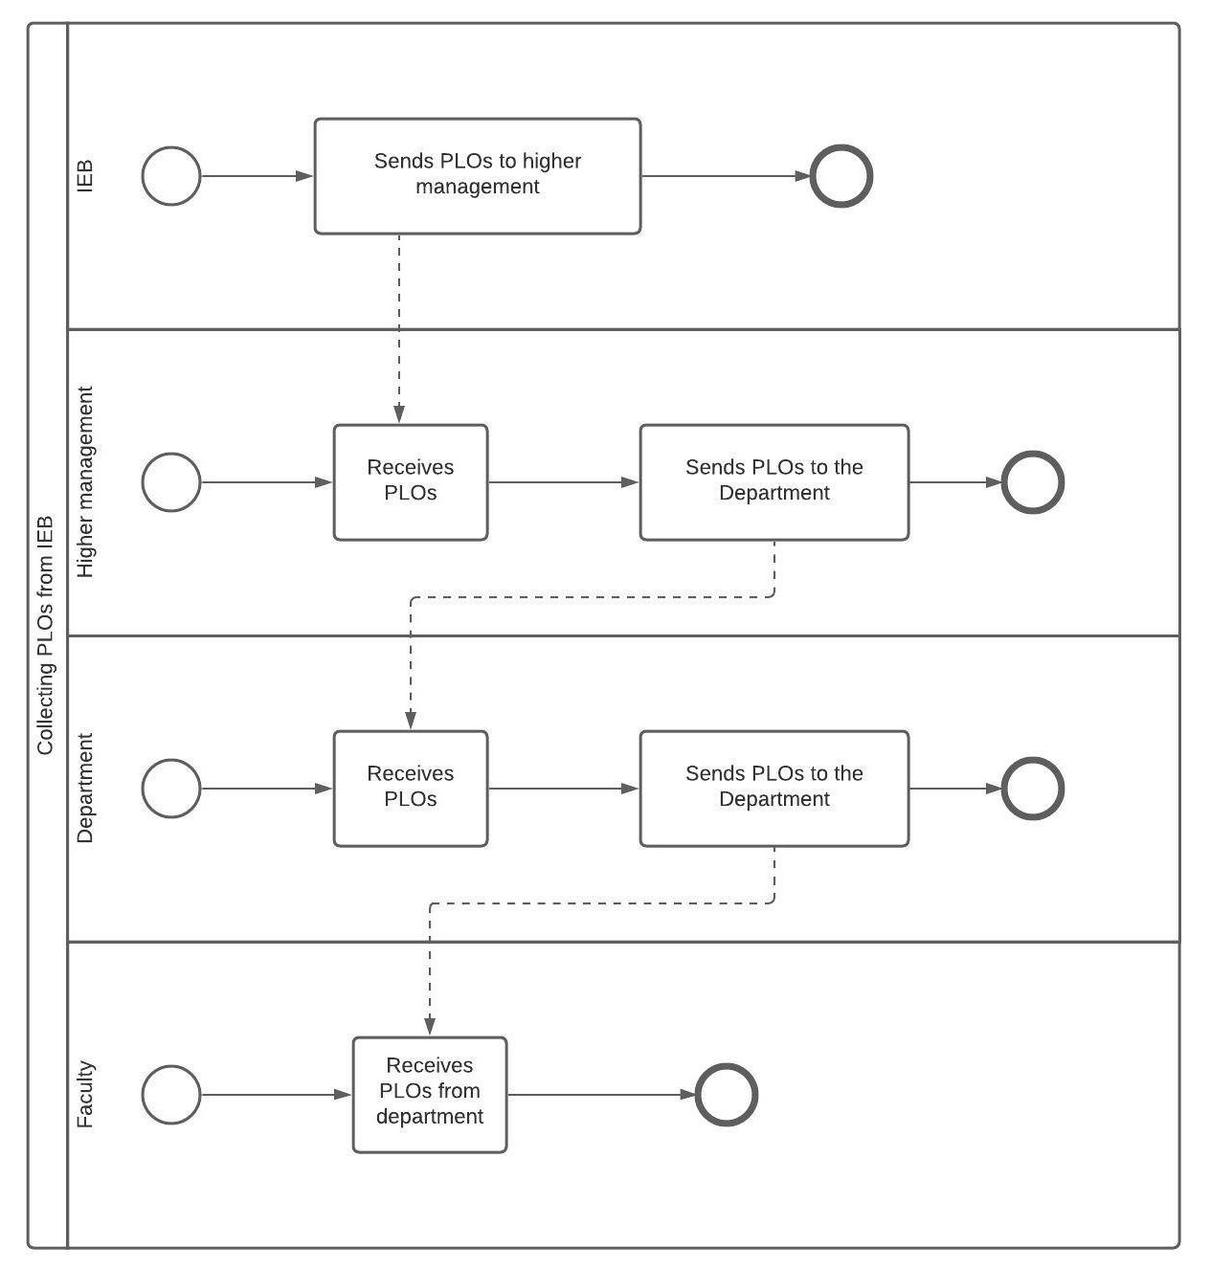**C. Process Diagram (AS-IS):**

Figure 2: Collecting PLOs from IEB

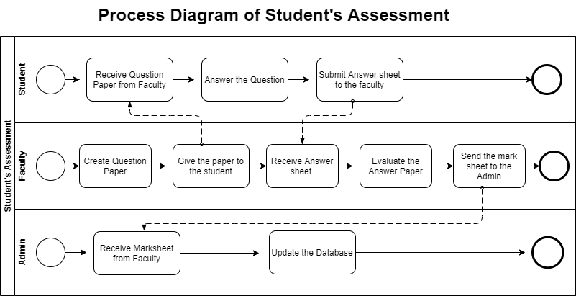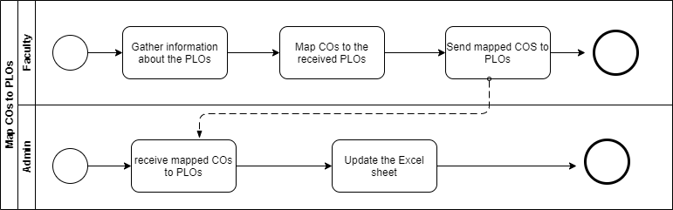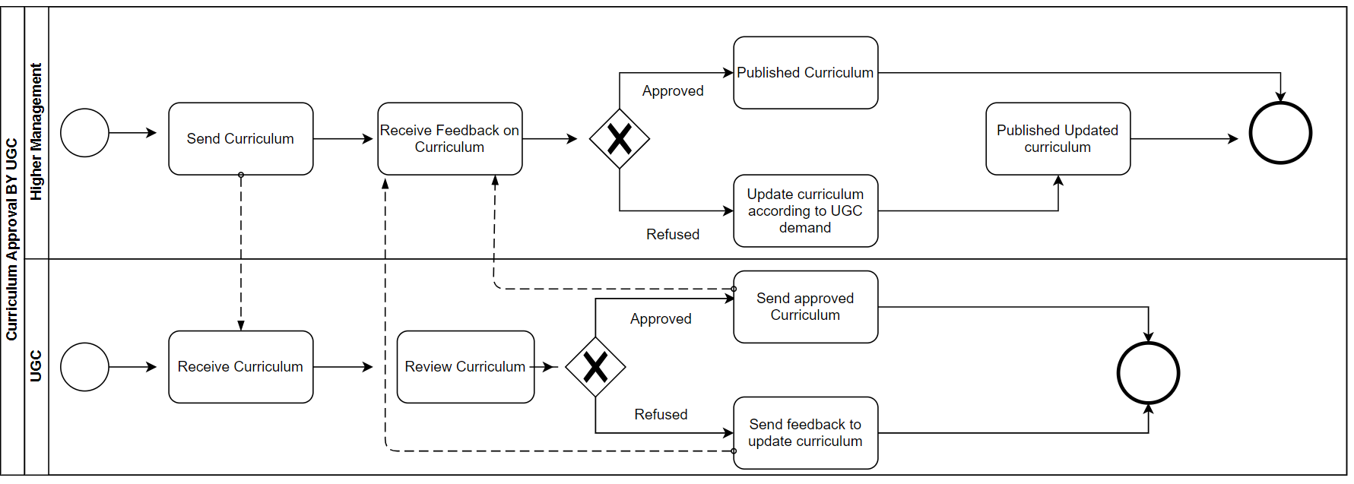

Figure 3 Assessment of Students

Figure 4 Mapping of COs to PLOs

Figure 5 Curriculum Approval by UGC

**D. Problem Analysis of the Existing System:**

|  |  |  |  |  |
| --- | --- | --- | --- | --- |
| Process Name | Stakeholders | Concerns  (Problems) | Analysis (Reason of  the Problem) | Proposed Solution |
| STUDENT’S ASSESSMENT | **1.Faculty**  **2.Admin** | The Faculty members  have to provide mark sheet  to Admin and then  the Admin enters the  mark sheet into the  Database. This  process becomes too  time consuming and  uses up a lot of extra  resources. | Since the faculty has to send the mark sheet all the way to the admin before getting uploaded to the database, it takes up much of the time and also uses unnecessary resources. | Our software allows the faculty to directly update the marks to the database. Hence, the use or participation of admin is not required. |
| PLO/CO Achievement Analysis | **1.Faculty** | The CO, PLO achievement analysis has to be done by the faculty by manually entering marks of each student to finalize whether they pass or fail. The analysis has to be sent to the admin to be uploaded to the database. | The entire CO, PLO achievement analysis table and the passing of the data is extremely time consuming. | Our software is designed to do the entire CO, PLO achievement analysis by itself. All the faculty has to do is enter the marks in the desired field. |

**E. Rich Picture of Proposed System:**

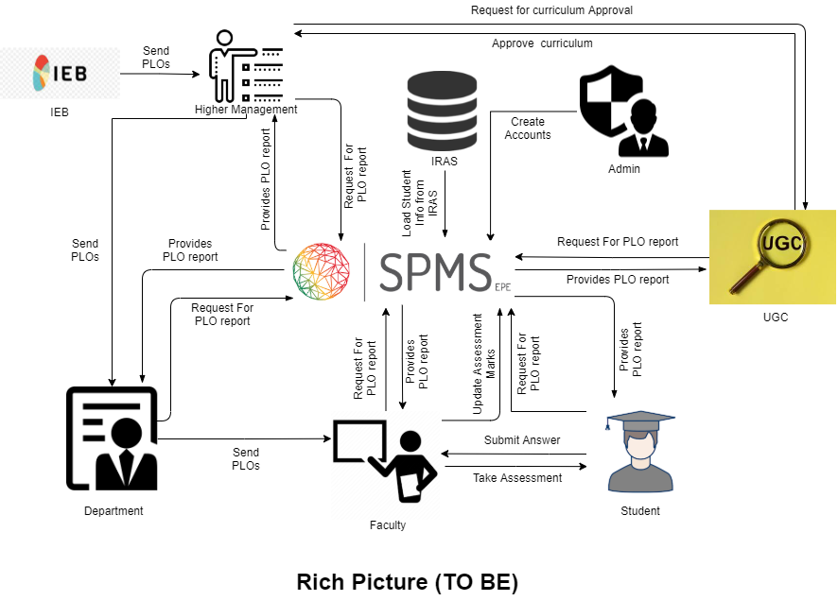

Figure 6Rich Picture (TO-BE)

**F. Six Element Analysis of Proposed System:**

|  |  |  |  |  |  |  |
| --- | --- | --- | --- | --- | --- | --- |
| Process | System Roles | | | | | |
| Human | Non-Comp  Hardware | Computing  Hardware | Software | Database | Network &  Communication |
| STUDENT’S ASSESSMENT | **1.Faculty :**  a)Create Question Paper.  b) Takes exam of  students in the  form of quizzes,  midterm and final  term by providing  questions.  c) Create  assessment report.  d) Updates assessment marks directly to SPMS  **2.Student:**  a) Answers the questions  provided by  Faculty.  b) submit the answer paper to the faculty. | **1.Paper:**  a) Used to  prepare hardcopy  of question  papers that are  used to assess  students in  exams.  b) Used to  prepare hardcopy  assessment  report.  c) Used to  provide hardcopy  of answer script  to the faculty.  **2.Stationery:**  a) Used to check  hardcopy of  answer script  provided by  students.  b) Used to fill  answer scripts  that are to be  provided to  faculty.  **3.Store Room:**  a) Used to store  all hardcopy of  questions, answer scripts  and assessment  reports. | **1.Computer:**  a) Used to  prepare softcopy  of question  papers that are  used to assess  students in  exams.  b) Used to  prepare softcopy  assessment  report.  c) Used to  prepare softcopy  of answer script  to the faculty.  d) Used to store  all softcopy of  questions,  answer scripts  and assessment  reports.  **2.Printer:**  a) Used to print  the questions on  to paper.  b) Used to print  the assessment  report.  c) Used to print  the answer script. | **1.Microsoft Word:**  a) Used to prepare  softcopy of question  papers that are used  to assess students in  exams.  b) Used to prepare  softcopy of answer  script to faculty.  **2.Microsoft** Excel :  a) Used to prepare  softcopy assessment  report.  **3.Gmail :**  a) Used to send  softcopy of  questions, answer  scripts and  assessment reports  to designated  personnel. | **1.Google Drive:**  a) Used to store and  backup all softcopy  of questions,  answer scripts and  assessment reports  on the internet.  2. **SPMS** - Updates and stores mark sheet in MySQL | **1.ISP:**  a) Provides  Internet service so  that the use of  Gmail, Google  Drive and SPMS  is possible. |
| Curriculum Approval by UGC | **1.Higher**  **Management:**  a) Forms a  committee of  faculty to prepare  a curriculum in  accordance to the  guideline provided  by UGC.  b) Receives  proposed  curriculum  provided by the  designated faculty  committee.  c) Requests UGC  for approval of  curriculum.  d. Receives  approval or  necessary  correction details  from UGC.  e) Sends  confirmation of  approved/corrected curriculum to  admin for storing.  **2.UGC:**  a)Receives  request from  higher  management for  approval of  curriculum.  b) Sends approval  or necessary  correction details  of curriculum to  higher  management.  c) Provides  guidelines to  higher  management for  preparing the  curriculum. | **1.Paper:**  a) Used to  prepare hardcopy  of faculty  committee  details, UGC guidelines,  proposed/  corrected curriculum,  approved  curriculum.  **2.Stationery:**  a) Used for  handwritten  mind mapping in  regards to faculty  committee  details,  proposed/corrected curriculum,  approved  curriculum.  **3.Store Room:**  a) Used to store  hardcopy of  approved  curriculum. | **1.Computer:**  a)Used to  receive, store and  analyze UGC  guidelines.  b) Used to  prepare and  store softcopy of  faculty  committee  details,  proposed/  corrected curriculum,  and approved  curriculum.  **2.Printer:**  a) Used to print  hardcopy of  faculty  committee  details, UGC  guidelines,  proposed/  corrected curriculum,  approved  curriculum. | **1.PDF Reader:**  a) Used to view and  store the softcopy of  received guidelines  from UGC, faculty  committee details,  proposed/corrected  curriculum and  approved curriculum  in PDF format.  **2.Microsoft Word:**  a) Used to prepare,  view and store  softcopy of faculty  committee details,  proposed/corrected  curriculum and  approved curriculum  in word format.  **2.Microsoft Excel:**  a) Used to prepare  softcopy for the  mapping of CO to PO  while creating  courses for the  curriculum.  **3.Gmail :**  a)Used to send  softcopy of faculty  committee details,  UGC guidelines,  proposed/corrected  curriculum,  approved curriculum  to designated  personnel. | **1.Google Drive:**  a) Used to store and  backup all softcopy  of faculty  committee details,  UGC guidelines,  proposed/corrected  curriculum,  approved  curriculum on the  internet. | **1.ISP:**  a) Provides  Internet service so  that the use of  Gmail, Google  Drive  is possible. |
| Collecting  PLOs from IEB | **1. IEB:**  a) Send PLOs to higher  management.  **2.Higher**  **Management:**  a) Receives PLOs from IEB  b) Send PLOs to the department.  **3.Department:**  a)Send the PLOs to the Faculty  **4.Faculty:**  a) Receives  PLOs from the Department. | **1.Paper:**  a) Used to  prepare hardcopy  Of the PLOs  **2.Stationery:**  a) Used for  handwritten  assessment to  create PLO  report.  **3.Store room:**  a) Used to store  hardcopy of PLO  report. | **1.Computer:**  a) Used to  prepare and  store softcopy of  PLO report.  **2.Printer:**  a) Used to print  hardcopy of PLO report | **1.PDF Reader:**  a) Used to view and  store the softcopy of  PLO report  **2. Microsoft Excel:**  a) Used to prepare,  view and store  softcopy of PLO  report in Excel Shit.  **3.Gmail:**  a. Used to  send/receive  softcopy of  PLOs from IEB to Higher management to faculty to Admin personnel. | **1.Google Drive:**  a) Used to store and  backup all softcopy  of PLO Report on the  internet. | **1.ISP:**  a) Provides  Internet service so  that the use of  Gmail, Google  Drive  is possible. |
| Getting student information for courses enrolled |  |  | **Server Computer –** SPMS sends request to IRAS for student information on courses enrolled each semester through API. | **1.SPMS:**  a) Sends request to IRAS for Student information on courses enrolled each semester through API.  **2. IRAS:**  a) Sends requested information to SPMS. | **1.MySQL :**  Stores Student information on courses enrolled each semester | **1.ISP:**  SPMS and IRAS requires internet which is provided by ISP. |
| Viewing the required PLO Report | 1.**UGC**  a) Request for information on PLO report  b) Get the information from the system.  2.**Higher Management**  a) Request for information on PLO report  b) Get the information from the system.  3.**Department**  a) Request for information on PLO report  b) Get the information from the system.  4.**Faculty**  a) Request for information on PLO report  b) Get the information from the system.  5.**Student**  a) Request for information on PLO report  b) Get the information from the system. |  | 1.**Computer**:  Use to browse PLO report from SPMS.  2.**Phone**:  Use to browse PLO report from SPMS | 1.**SPMS**: Prepare the required PLO report for stack holders  2. **Web Browser**:  Access the SPMS website | 1. **MY SQL**: Store the necessary data which are used to made the POL report. | 1. **ISP**: Provides Internet service to the Stack Holders so that they can access the information. |

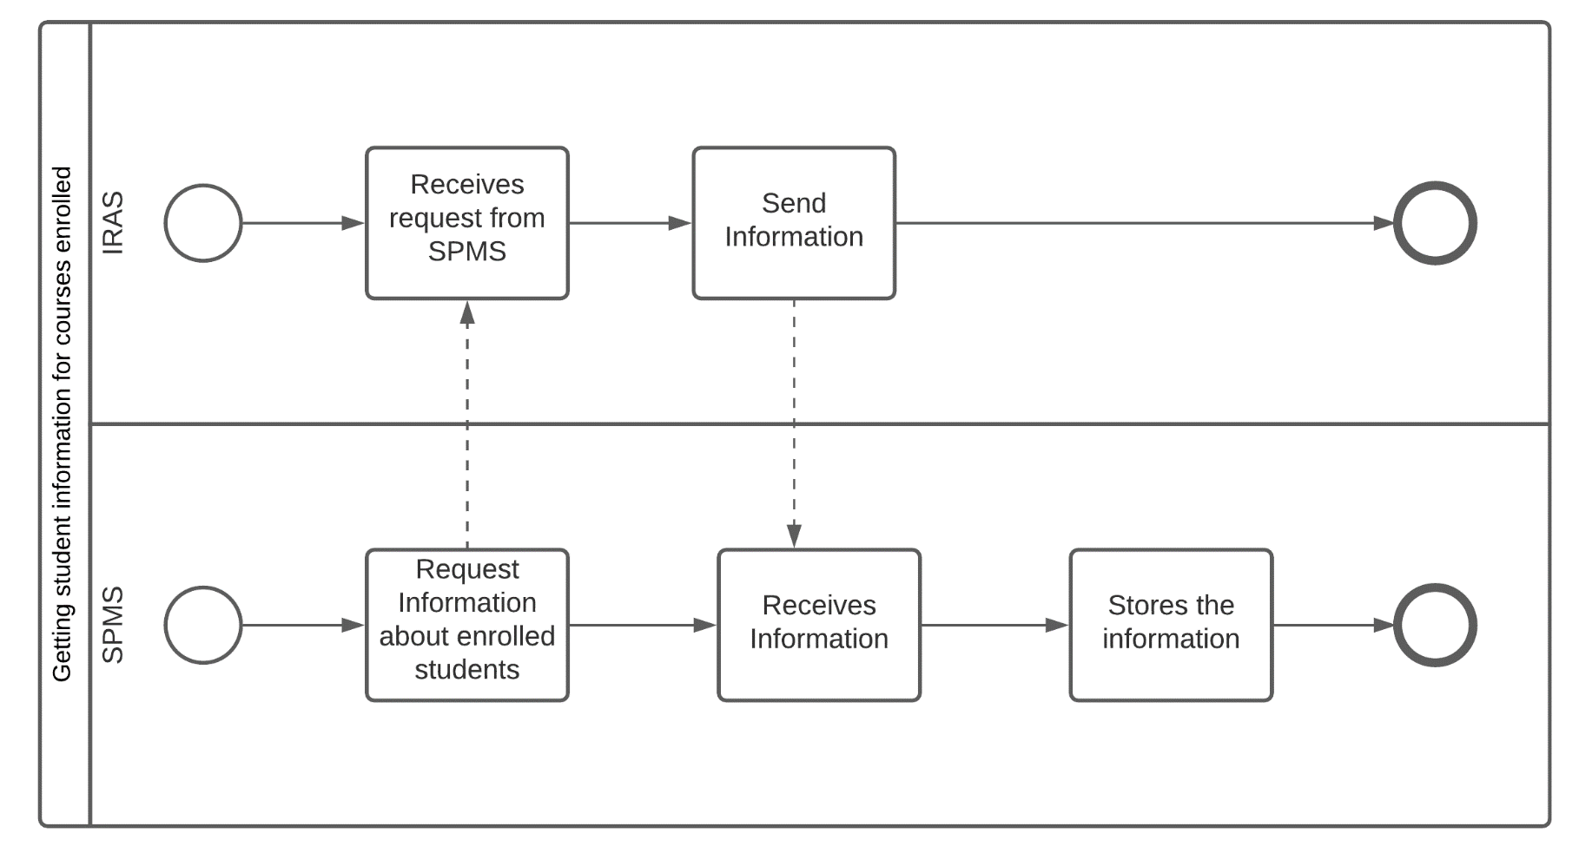**G. Process Diagram (TO-BE):**

Figure 7: Getting Student Information

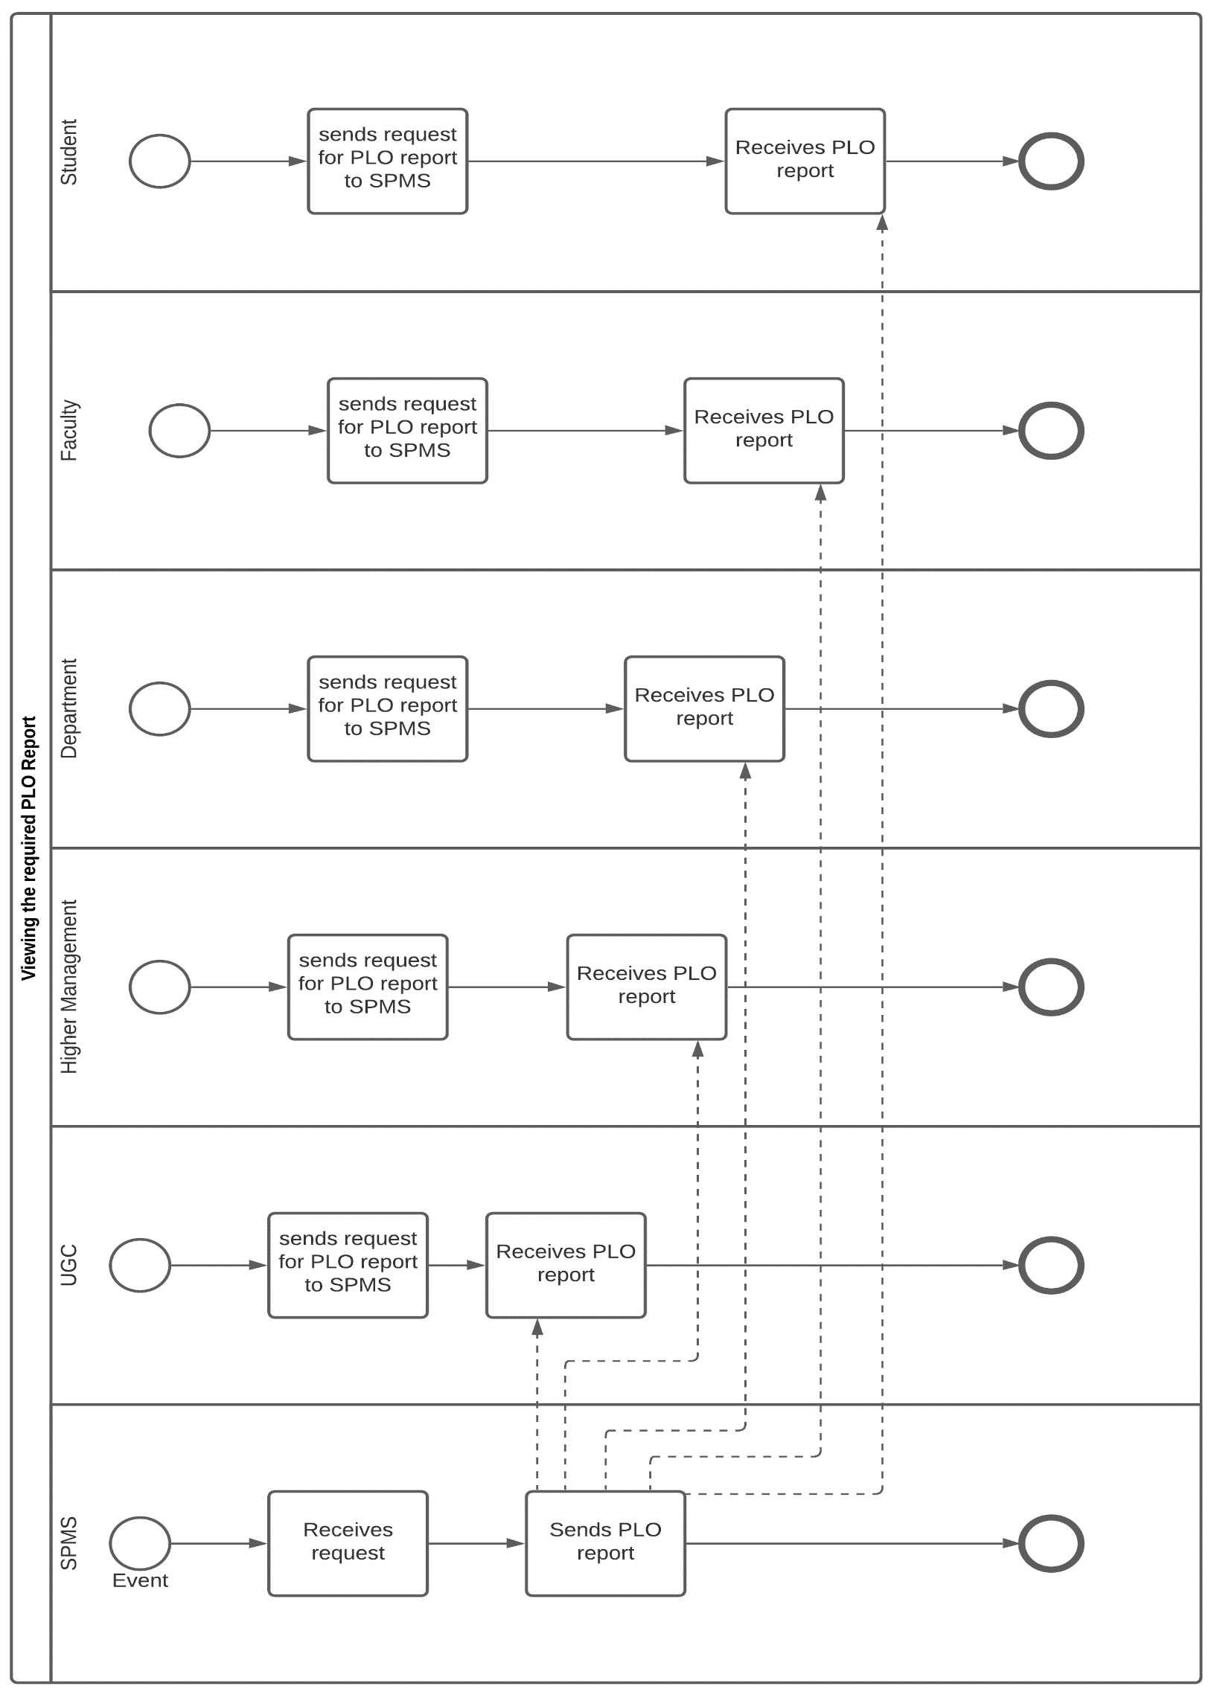

Figure 8 Viewing PLO Reports

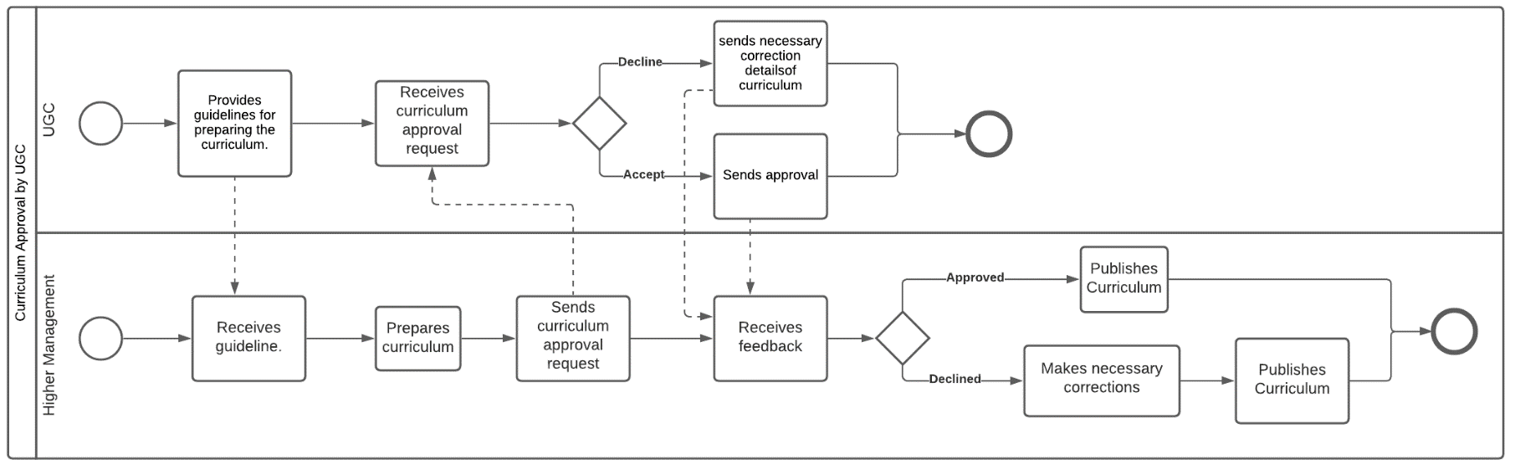

Figure 10 Curriculum Approval by UGC

Figure 9 Assessment of Students

